

ESTD: 2009
CMR TECHNICAL CAMPUS
UGC AUTONOMOUS
Accredited by NBA & NAAC with ‘A’ Grade
Approved by AICTE, New Delhi and JNTU Hyderabad

DEPARTMENT OF INFORMATION TECHNOLOGY
Date: 29 Jan 2026
LETTER OF ACCEPTANCE

TO,
PRC,
CMRTC,
Medchal.

Respected Sir,
Subject: Acceptance of Major Project

We K.Naina Harshitha (227R1A1230), S.Ganesh (227R1A1252), J.Adithya (227R1A1222) of Batch No. 19 of IT-A, are doing major Project on “Design and Implementation of an Intelligent Email Automation System Using RPA and Generative AI.” under the guidance of G.Shankar Sir.

Guide Name : G.Shankar
Guide Signature :



DEPARTMENT OF INFORMATION TECHNOLOGY
“Design and Implementation of an Intelligent Email Automation System Using RPA and Generative AI.”
ABSTRACT
Email communication generates a large volume of messages that are difficult to manage manually, especially when emails contain attachments, multilingual content, and require timely responses. This project presents the design and implementation of an intelligent email automation system by integrating Robotic Process Automation (RPA) with Generative Artificial Intelligence (AI). The system automatically reads incoming emails, analyzes email content and attachments, and generates concise summaries using Generative AI.To support global communication, the system detects the language of incoming emails and performs translation when required. A key feature of the proposed system is the human-in-the-loop mechanism, where summarized information and AI-generated reply suggestions are sent to the user through WhatsApp Web for review and approval. Only after user confirmation does the system send automated responses, ensuring safety, accuracy, and user control.

EXISTING SYSTEM
“E-Mail Assistant — Automation of E-Mail Handling and Management using RPA (2022)”
This paper demonstrates how UiPath RPA can automate basic email handling tasks, such as sorting and organizing emails. The main focus is on reducing manual effort in email management using rule-based automation.
”RPA-Driven Email Automation (2024)”
This system uses RPA to automatically detect spam and classify emails based on predefined rules. Its primary objective is email filtering, not semantic understanding of email content or intelligent response generation.
“AI-Powered Email Automation (2025)”
This work introduces an AI-based email automation system developed with UiPath to handle customer emails. While it automates reply generation, it relies mainly on fixed workflows and predefined templates rather than dynamic content understanding.



DEPARTMENT OF INFORMATION TECHNOLOGY

DISADVANTAGES
- Depend heavily on rule-based processing with limited intelligence
- Lack deep understanding of email content and attachments
- No effective email or document summarization
- Limited or no multilingual support
- Use template-based automated replies only
- Absence of user approval (human-in-the-loop) mechanism

PROPOSED SYSTEM

The proposed system automates email processing using UiPath Robotic Process Automation integrated with Generative AI. It retrieves incoming emails from the mail server using the IMAP protocol and extracts the email subject, body, and attachments. If attachments such as PDF or document files are found, they are saved locally and their text content is extracted. The email body and attachment text are summarized separately using Generative AI to reduce lengthy content. The summarized information is sent to the user through WhatsApp Web automation for quick notification. The system detects the language of the received email and translates the content into the required language. User approval is taken through WhatsApp before sending the reply. Once approved, the final response is sent automatically using the SMTP protocol. This system reduces manual effort and improves communication efficiency.

ADVANTAGES
- Reduces manual effort by automating email reading, summarization, and replying.
- Provides clear and concise summaries of long emails and attached documents.
- Supports multilingual communication through language detection and translation.
- Sends instant notifications to users through WhatsApp for faster awareness.
- Generates intelligent replies using Generative AI instead of fixed rules based.
- Includes user approval before sending replies, ensuring safe automation.
- Improves productivity and response time in organizations.
- Can be used across different domains such as education, business, and customer support.



DEPARTMENT OF INFORMATION TECHNOLOGY

HARDWARE AND SOFTWARE REQUIREMENTS
Software Requirements:
Operating System :Windows 10 / 11
Development Tool :UiPath Studio Community
Framework :UiPath Robotic Process Automation (RPA)
Web Browser :Google Chrome / Microsoft Edge
Hardware Requirements:
Processor :Intel Core i3 or higher
RAM :8 GB
Storage :Minimum 2 GB free disk space
Peripherals :Keyboard, Mouse



DEPARTMENT OF INFORMATION TECHNOLOGY

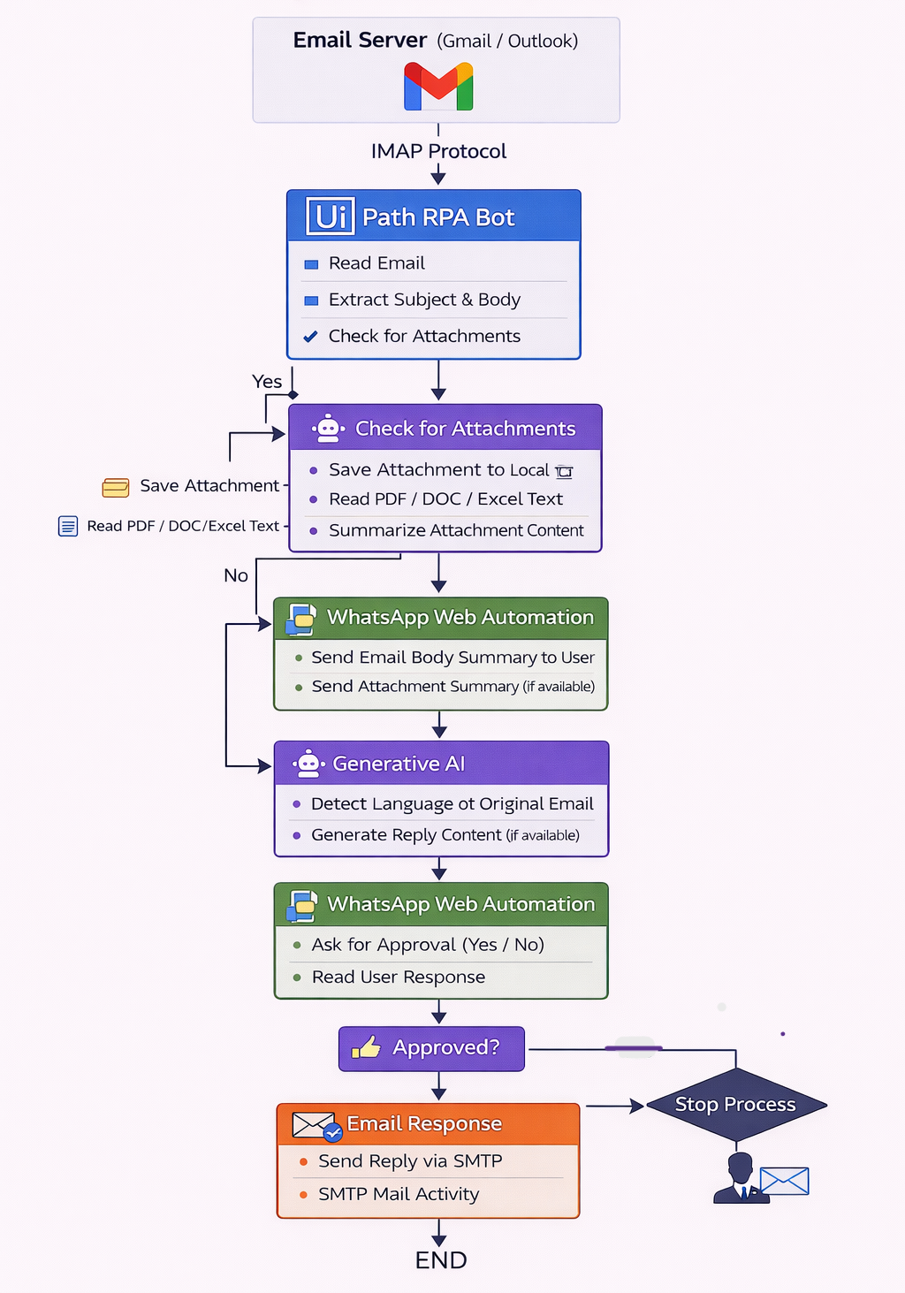
SYSTEM ARCHITECTURE



DEPARTMENT OF INFORMATION TECHNOLOGY

The system architecture of the proposed email automation system integrates Email Services, Robotic Process Automation (RPA), Generative Artificial Intelligence, and WhatsApp Web automation into a unified workflow. Incoming emails are monitored and extracted by UiPath RPA bots, which read the email content and attachments. This data is then processed by the Generative AI module to understand, summarize, and generate appropriate reply suggestions, along with language detection and translation when required. The summarized information and AI-generated responses are sent to the user through WhatsApp Web for review and approval, ensuring a human-in-the-loop mechanism. Once approval is received, the RPA bot automatically sends the finalized response through the email server, enabling efficient, intelligent, and controlled email management.

